**Exercise 1: Control Structures**

**Scenario 1:**

The bank wants to apply a discount to loan interest rates for customers above 60 years old.

**PL/SQL Query:**

BEGIN

FOR rec IN (

SELECT c.customer_id, l.loan_id, l.interest_rate

FROM customers c

JOIN loans l ON c.customer_id = l.customer_id

WHERE c.age > 60

) LOOP

UPDATE loans

SET interest_rate = interest_rate - 1

WHERE loan_id = rec.loan_id;

DBMS_OUTPUT.PUT_LINE('1% discount applied to Customer ID: ' || rec.customer_id);

END LOOP;

END;

/

**Script Output:**

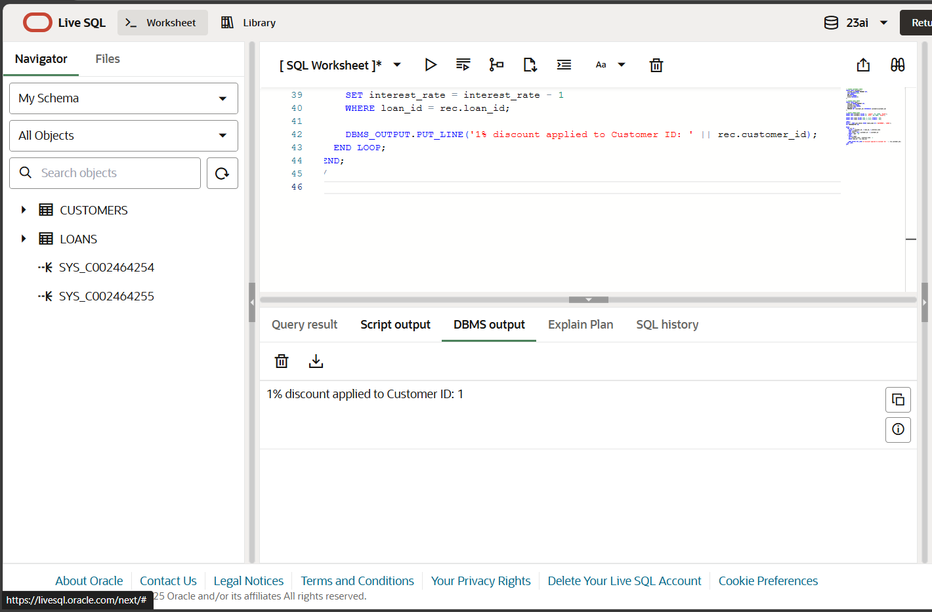

**Scenario 2:**

A customer can be promoted to VIP status based on their balance.

**PL/SQL Query:**

BEGIN

FOR rec IN (

SELECT customer_id, balance

FROM customers

WHERE balance > 10000

) LOOP

UPDATE customers

SET IsVIP = 'TRUE'

WHERE customer_id = rec.customer_id;

DBMS_OUTPUT.PUT_LINE('Customer ID ' || rec.customer_id || ' promoted to VIP.');

END LOOP;

END;

/

**Script Output:**

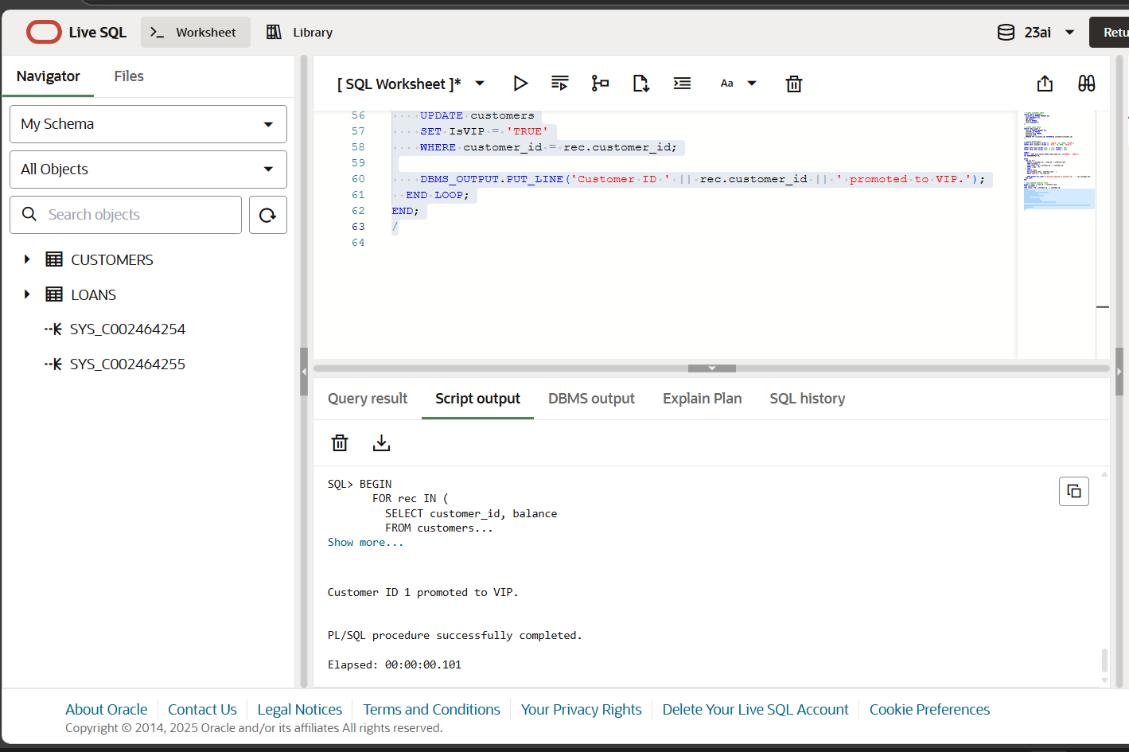

**Scenario 3:**

The bank wants to send reminders to customers whose loans are due within the next 30 days.

**PL/SQL Query:**

BEGIN

FOR rec IN (

SELECT c.customer_id, c.name, l.loan_id, l.due_date

FROM loans l

JOIN customers c ON l.customer_id = c.customer_id

WHERE l.due_date BETWEEN SYSDATE AND SYSDATE + 30

) LOOP

DBMS_OUTPUT.PUT_LINE(

'Reminder: Loan ID ' || rec.loan_id || ' for Customer ' || rec.name ||

' is due on ' || TO_CHAR(rec.due_date, 'DD-MON-YYYY')

);

END LOOP;

END;

/

**Script Output:**

